**STATISTICAL FUNCTIONS AND APPLICATIONS**

**Assignment Number 3**

Register Number: 1740256

**Date:** 18/09/2017

--------------------------------------------------------------------------------------------

**Question 1**

**Aim** - Choose any 2 data sets consisting of 25 and 35 values respectively. Compute mean, median, mode, Geometric & Harmonic Mean separately.

**Procedure** –

1. Mean.  
   1. This can be obtained through the ‘Average’ function. In a blank cell, use the ‘=Average’ function, selecting the ‘Income’ column as the inputs in the function.   
   2. The resulting function will be: =AVERAGE(Table2[Income]). Press Enter.  
     
     
   B) Median.   
   1. This can be obtained by using the ‘Median’ function. In a blank cell, use the ‘=Median’ function, selecting the ‘Income’ column as the input.  
   2. The resulting function will be: =MEDIAN(Table2[Income]). Press Enter.  
     
     
   C) Mode.   
   1. This can be obtained by using the ‘Mode’ function. In a blank cell, use the ‘=Mode’ function, selecting the ‘Income’ column as the input.  
   2. The resulting function will be: =MODE(Table2[Income]). Press Enter.  
     
     
   D) Geometric Mean.  
   1. This can be obtained by using the ‘Geometric Mean’ function. In a blank cell, use the ‘=Geomean’ function, selecting the ‘Income’ column as the input.  
   2. The resulting function will be: =GEOMEAN(Table2[Income]). Press Enter.  
     
     
   E) Harmonic Mean.  
   1. This can be obtained by using the ‘Harmonic Mean’ function. In a blank cell, use the ‘=Harmean’ function, selecting the ‘Income’ column as the input.  
   2. The resulting function will be: =HARMEAN(Table2[Income]). Press Enter.

**Calculations –**

For the 1st data set (25 values)– For the 2nd data set (35 values) –

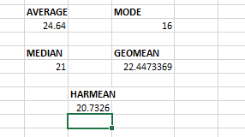 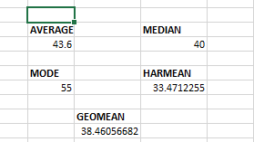

**Conclusions –**

1st data set – 2nd data set -

Mean was found to be 24.64. Mean was found to be 24.64.

Median was found to be 21. Median was found to be 21.

Mode was found to be 16. Mode was found to be 16.

Geometric Mean was found to be 22.44733. Geometric Mean was found to be 22.44733.

Harmonic Mean was found to be 20.7326. Harmonic Mean was found to be 20.7326.

--------------------------------------------------------------------------------------------

THE END

--------------------------------------------------------------------------------------------